



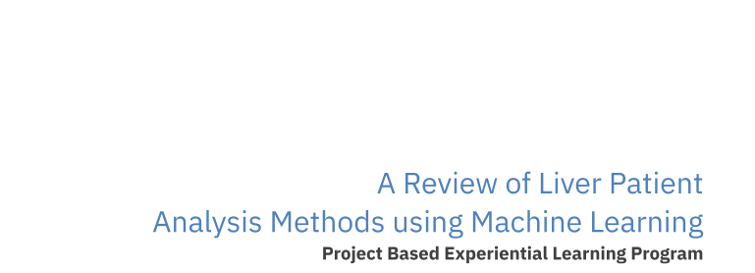

**A Project Report**

A Review of Liver Patient Analysis Methods using Machine Learning

Team ID : NM2023TMID17396

Team Leader : JENOVA REBOLIN J

Team members : MAHENDRAN M

MATHAN E

MUKESH S

**INDEX**

1. **INTRODUCTION**
   1. Overview

1.2 Purpose

1. **Problem Definition & Design Thinking**
   1. Empathy Map

2.2 Ideation & Brainstorming Map

1. **RESULT**
2. **ADVANTAGES & DISADVANTAGES**
3. **APPLICATIONS**
4. **CONCLUSION**
5. **FUTURE SCOPE**
6. **APPENDIX**

8.1 Source Code

**A Review of Liver Patient Analysis Methods**

**Using Machine Learning**

**1. INTRODUCTION**

1.1 OVERVIEW

Liver diseases averts the normal function of the liver. This disease is caused by an assortment of elements that harm the liver. Diagnosis of liver infection at the preliminary stage is important for better treatment. In today’s scenario devices like sensors are used for detection of infections. Accurate classification techniques are required for automatic identification of disease samples. This disease diagnosis is very costly and complicated. Therefore, the goal of this work is to evaluate the performance of different Machine Learning algorithms in order to reduce the high cost of liver disease diagnosis. Early prediction of liver disease using classification algorithms is an efficacious task that can help the doctors to diagnose the disease within a short duration of time. In this project we will analyses the parameters of various classification algorithms and compare their predictive accuracies so as to find out the best classifier for determining the liver disease. This project compares various classification algorithms such as Random Forest, Logistic Regression, KNN and ANN Algorithm with an aim to identify the best technique. Based on this study, Random Forest with the highest accuracy outperformed the other algorithms and can be further utilized in the prediction of liver disease and can be recommended to the user

1.2 Purpose

The purpose of a review of liver patient analysis methods using machine learning is to assess the effectiveness of machine learning algorithms in analysing patient data and predicting liver diseases' diagnosis, prognosis, and treatment planning. The review aims to evaluate the strengths and limitations of machine learning algorithms in liver patient analysis and identify potential areas for future research.

The review also aims to provide healthcare providers and researchers with an understanding of the current state of the field of machine learning in liver patient analysis, including the types of machine learning algorithms that are commonly used, the sources of patient data that are analysed, and the accuracy and reliability of machine learning models in predicting liver diseases.

Overall, the purpose of a review of liver patient analysis methods using machine learning is to provide a comprehensive assessment of the potential benefits and challenges associated with the use of machine learning algorithms in liver patient analysis and to identify future research directions.

**2. Problem Definition & Design Thinking**

2.1 Empathy Map

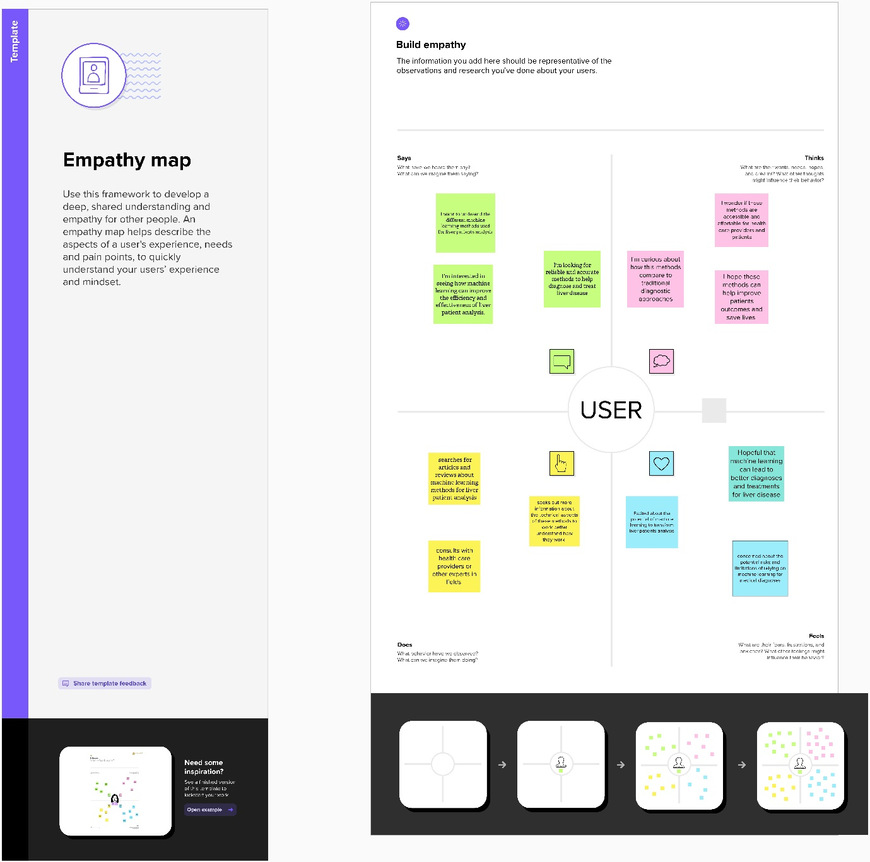

2.2 Ideation & Brainstorming Map

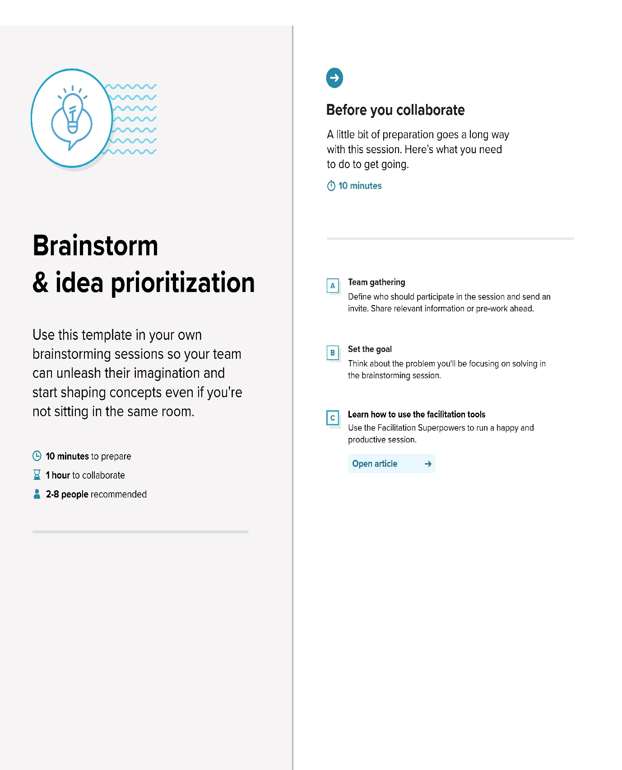

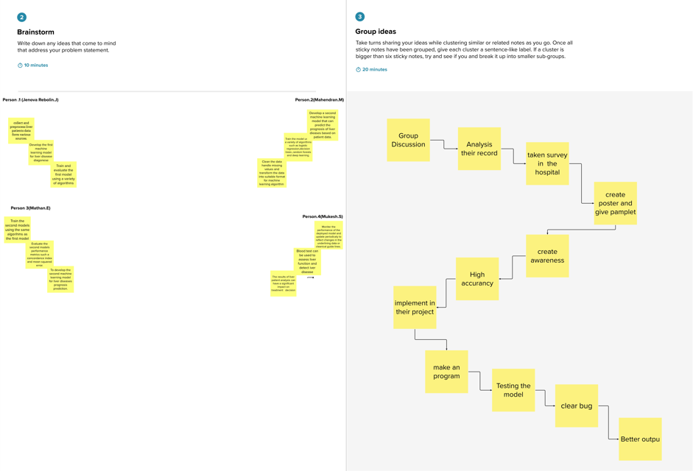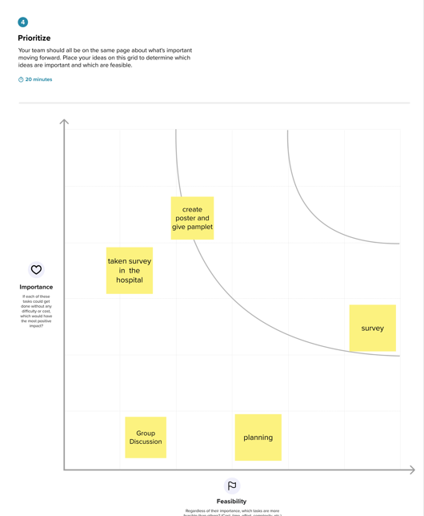

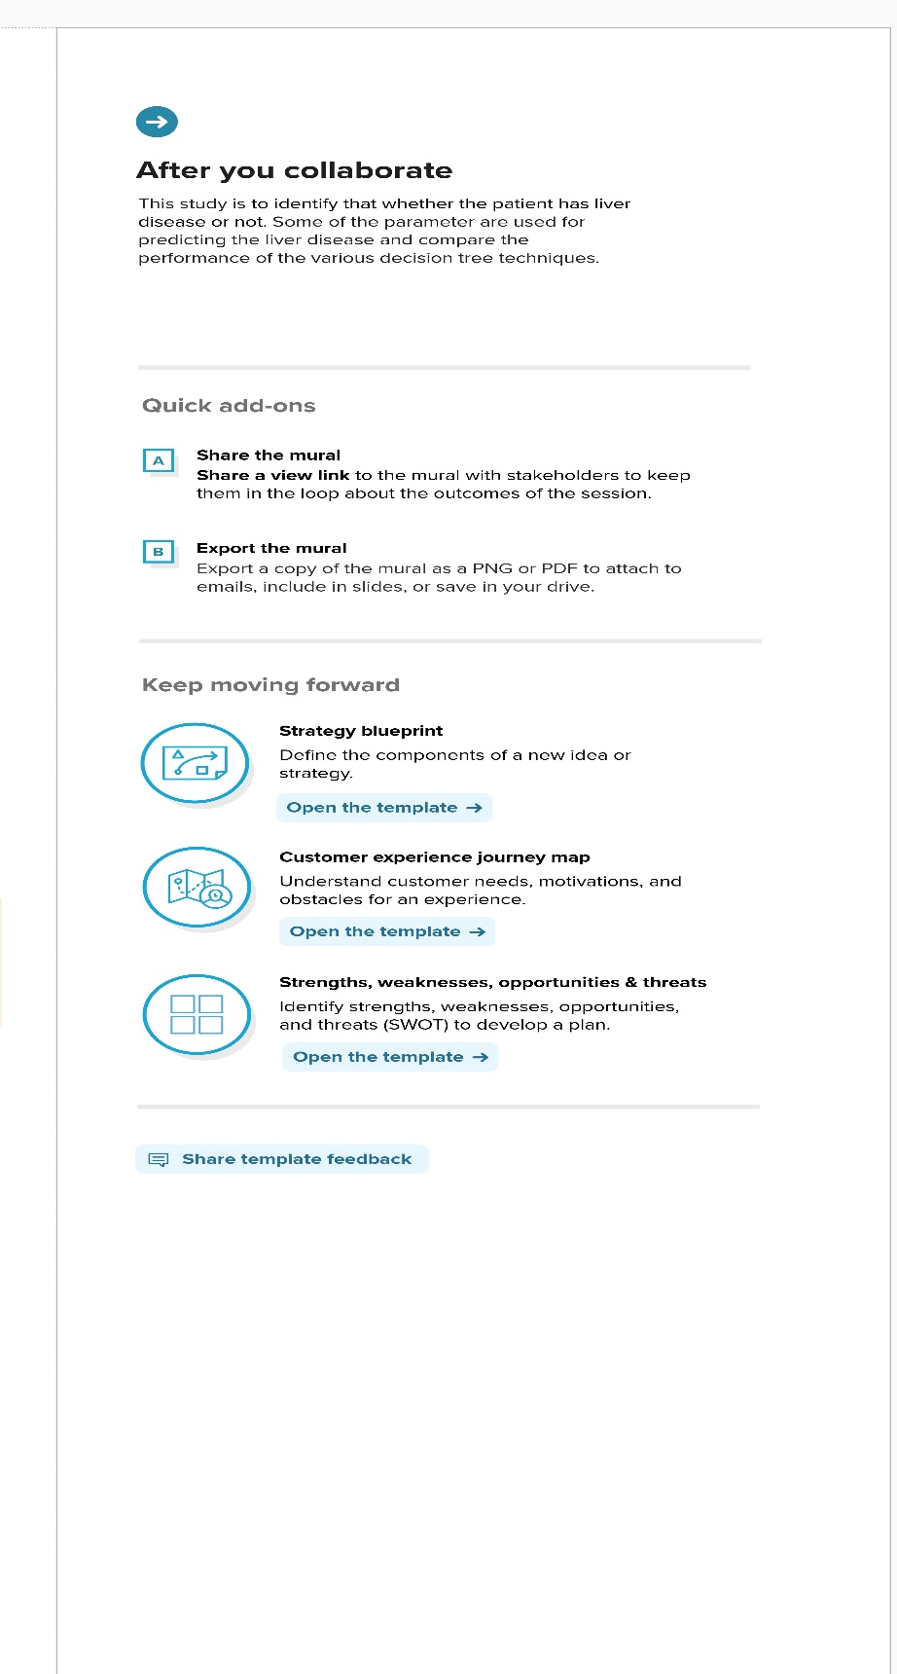

**3.Result**

Output:

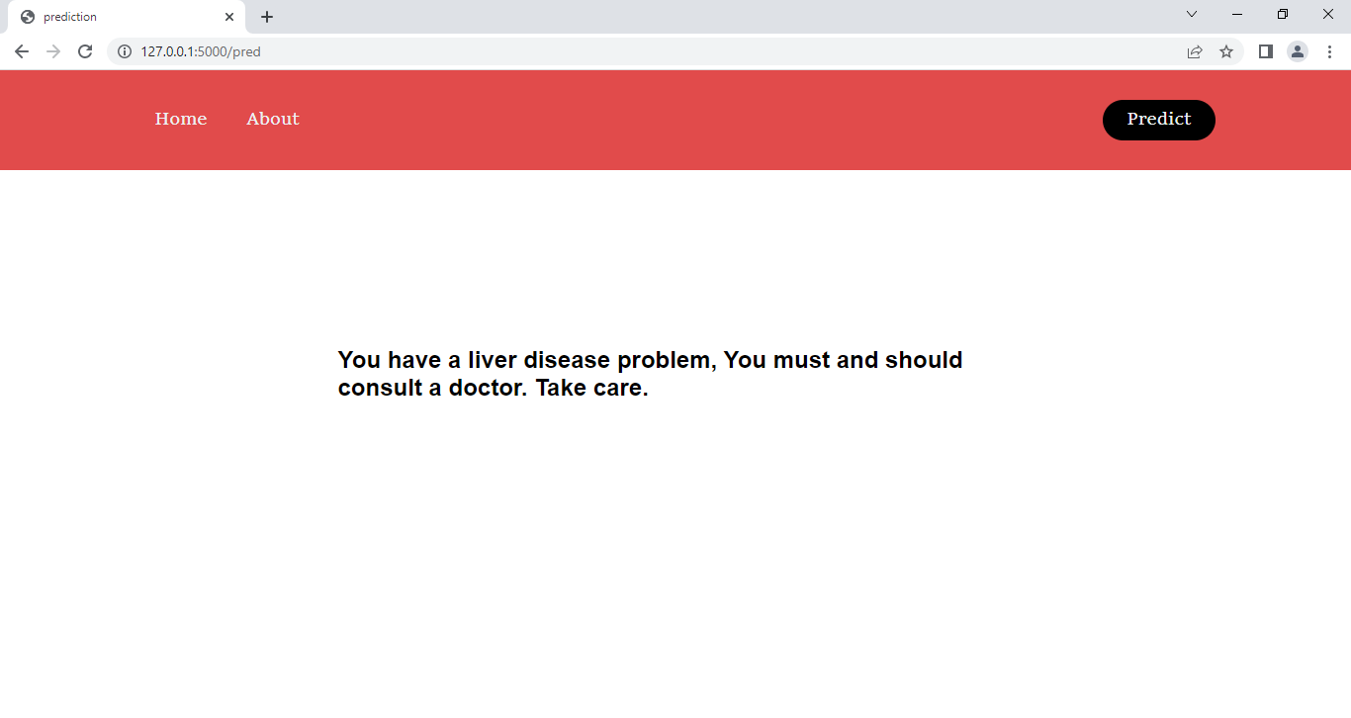

**4. ADVANTAGES & DISADVANTAGES**

Advantages

1. Improved Accuracy: Machine learning algorithms can identify patterns and correlations in large amounts of data that may not be easily discernible by humans. As a result, machine learning algorithms can improve the accuracy of liver patient analysis methods.
2. Speed: Machine learning algorithms can analyse large amounts of data quickly, which can be particularly useful when dealing with large data sets. This can save time and resources when compared to traditional analysis methods.
3. Personalized Treatment: Machine learning algorithms can be used to develop personalized treatment plans for liver patients. By analysing individual patient data, machine learning algorithms can help doctors tailor treatment plans to specific patient needs.
4. Early Detection: Machine learning algorithms can be used to detect liver diseases at an early stage, allowing doctors to provide early intervention and improve the patient's prognosis.

Disadvantages:

1. Limited Data: Machine learning algorithms rely on large amounts of data to function effectively. If there is a limited amount of data available, the accuracy of the algorithm may be compromised.
2. Bias: Machine learning algorithms can be biased if the data used to train the algorithm is biased. This can lead to inaccurate results and may have negative consequences for liver patients.
3. Complexity: Machine learning algorithms can be complex, and it can be difficult for non-experts to understand how they work. This can make it difficult for doctors to use these methods in clinical practice.
4. Data Privacy: Machine learning algorithms rely on patient data to function effectively. As a result, there may be concerns about data privacy and patient confidentiality. It is important to ensure that patient data is protected when using these methods.

5. APPLICATION

Application of Job Prediction

Job prediction is not directly applicable to liver patient analysis methods using machine learning. However, the use of machine learning algorithms in liver patient analysis can help healthcare providers identify patients who may be at higher risk of developing liver diseases, and as a result, they may need to modify their lifestyle or take preventive measures.

Machine learning algorithms can also help healthcare providers predict the prognosis of patients with liver diseases, which can help them develop more personalized treatment plans. By analysing patient data such as age, gender, medical history, and test results, machine learning algorithms can help healthcare providers predict how patients with liver diseases will respond to different treatments.

Overall, the application of machine learning in liver patient analysis can help healthcare providers make more informed decisions and improve patient outcomes. It is important to note that the use of machine learning algorithms should be complemented with clinical expertise and human judgment to ensure that patients receive the best possible care.

**6. CONCLUSION**

Conclusion:

The use of machine learning algorithms in liver patient analysis has the potential to improve the accuracy of diagnosis, prognosis, and treatment planning for liver diseases. Machine learning algorithms can analyze large amounts of patient data quickly and identify patterns and correlations that may not be easily discernible by humans. As a result, healthcare providers can make more informed decisions and provide more personalized care to liver patients. **7. FUTURE SCOPE**

Future Scope:

The future scope of liver patient analysis methods using machine learning is vast and promising. Here are some potential areas of future research:

1. Developing more accurate and reliable machine learning models: Researchers can continue to refine machine learning algorithms to improve their accuracy and reliability in liver patient analysis. This can include developing new machine learning models or improving existing ones.
2. Integration of multiple data sources: Researchers can explore the integration of multiple data sources, including genetic data, lifestyle data, and environmental data, to improve the accuracy of liver patient analysis. This can lead to more personalized treatment plans and better patient outcomes.
3. Development of decision support systems: Machine learning algorithms can be integrated into decision support systems that can help healthcare providers make more informed decisions about liver patient analysis and treatment planning.
4. Real-time monitoring: Machine learning algorithms can be used to monitor liver patients in real-time, providing healthcare providers with up-to-date information on patient health and enabling timely interventions when necessary.
5. Integration with other technologies: Machine learning algorithms can be integrated with other emerging technologies, such as wearable devices and telemedicine, to improve the accuracy and efficiency of liver patient analysis and treatment.

In conclusion, the future of liver patient analysis using machine learning is bright and holds a lot of promise for improving patient outcomes. Further research and development in this area will be crucial to fully realize the potential of machine learning algorithms in liver patient analysis.

**8. APPENDIX**

* 1. Source Code

1.app.py(Source Code)

from flask import Flask, render_template, request  
import pickle  
import joblib  
import numpy as np  
from sklearn.preprocessing import scale  
  
app = Flask(__name__)  
  
model = joblib.load('ETC.pkl')  
  
@app.route('/')  
def home():  
 return render_template('home.html')  
@app.route('/about')  
def about():  
 return render_template('about.html')  
@app.route('/predict')  
def perdict():  
 return render_template("predict.html")  
@app.route('/pred',methods=['post'])  
def predict():  
 sen1 = request.form['sen1']  
 sen2 = request.form['sen2']  
 sen3 = request.form['sen3']  
 sen4 = request.form['sen4']  
 sen5 = request.form['sen5']  
 sen6 = request.form['sen6']  
 sen7 = request.form['sen7']  
 sen8 = request.form['sen8']  
 sen9 = request.form['sen9']  
 sen10 = request.form['sen10']  
 sample_value = [[float(sen1), float(sen2), float(sen3), float(sen4), float(sen5), float(sen6), float(sen7), float(sen8),  
 float(sen9), float(sen10)]]

sample_value = np.array(sample_value)  
 sample_value = sample_value.reshape(1, -1)  
 *# Scale the data* sample_value = scale(sample_value)  
 *# Use the model to predict the outcome* prediction = model.predict(sample_value)  
  
 output = ' '  
 if prediction[0] == 1:  
 output = 'Liver Patient'  
 else:  
 output = 'Healthy'  
 return render_template('submit.html', prediction=output)  
if __name__ == "__main__":  
 app.run(debug=True)

1. home.html

<!DOCTYPE html>  
 <head>  
 <meta charset="utf-8">  
 <meta http-equiv="X-UA-Compatible" content="IE=edge">  
 <title>Welcome to Liver Patient Analysis</title>  
 <meta name="description" content="">  
 <meta name="viewport" content="width=device-width, initial-scale=1">  
 <link rel="stylesheet" href="/static/styles.css">  
 <link href="https://fonts.googleapis.com/css?family=Montserrat:500&display=swap" rel="stylesheet">  
 </head>  
 <body>  
 <header>  
   
 <nav>  
 <ul class="nav__links">  
 <li><a href="/">Home</a></li>  
 <li><a href="/about">About</a></li>  
 </ul>  
 </nav>  
 <a class="cta" href="/predict">Predict</a>  
   
 </header>  
   
 <div class="idp-text">  
 <h1> A Review of Liver Patient Analysis Methods Using Machine Learning</h1>  
 </div>  
 <div class="idp-b">  
 <a class="cta" href="/predict">Predict</a>  
 </div>  
 </body>  
</html>

1. about.html

<!DOCTYPE html>  
 <head>  
 <meta charset="utf-8">  
 <meta http-equiv="X-UA-Compatible" content="IE=edge">  
 <title>Prediction</title>  
 <meta name="description" content="">  
 <meta name="viewport" content="width=device-width, initial-scale=1">  
 <link rel="stylesheet" href="static/styles.css">  
 <link href="https://fonts.googleapis.com/css?family=Montserrat:500&display=swap" rel="stylesheet">  
 </head>  
 <body>  
 <header>  
   
 <nav>  
 <ul class="nav__links">  
 <li><a href="/">Home</a></li>  
 <li><a href="/about">About</a></li>  
 </ul>  
 </nav>  
 <a class="cta" href="/predict">Predict</a>  
   
 </header>  
  
  
 <div class="idp-p">  
 <h3> Introduction - Liver Patient Analysis</h3>  
  
 <p>  
 Liver diseases averts the normal function of the liver. Mainly due to the large amount of alcohol consumption liver disease arises. Early prediction of liver disease using classification  
 of liver disease using classification algorithms is an efficacious task that can help the doctors to diagnose the disease within a short duration of time. Discovering the existence of liver disease at an early stages a complex task for doctors. The main objective of this paper is to Analysis the parameters of various classification algorithms and compare their predictive accuracies so as to find out  
 the best classifier for determining the liver disease. This paper focuses on the related works of various authors on Liver disease such that algorithms were implemented using Weka tool that is a machine leaning software written in Java. Various attributes that are essential in the prediction of liver disease were examined and the dataset of liver patients were also evaluated.   
 This paper compares various classification algorithms such as Random Forest, Logistic Regression and Separation Algorithm with an aim to identity the best technique Based on this study, Random Forest with the highest accuracy out performed the other algorithms and can be further utilized in the prediction of liver disease commended.  
 </p>  
 </div>  
 <div class="idp-c">  
 <a class="cta" href="/predict">Predict</a>  
 </div>  
 </body>  
</html>

1. predict.html

<!DOCTYPE html>  
 <head>  
 <meta charset="utf-8">  
 <meta http-equiv="X-UA-Compatible" content="IE=edge">  
 <title>Prediction</title>  
 <meta name="description" content="">  
 <meta name="viewport" content="width=device-width, initial-scale=1">  
 <link rel="stylesheet" href="static/styles.css">  
 <link href="https://fonts.googleapis.com/css?family=Montserrat:500&display=swap" rel="stylesheet">  
 </head>  
 <body>  
 <header>  
   
 <nav>  
 <ul class="nav__links">  
 <li><a href="/">Home</a></li>  
 <li><a href="/about">About</a></li>  
 </ul>  
 </nav>  
 <a class="cta" href="/predict">Predict</a>  
   
 </header>  
  
  
 <div class="idp-p">  
 <h3> Introduction - Liver Patient Analysis</h3>  
  
 <p>  
 Liver diseases averts the nomal function of the liver. Mainly due to the large amount of alcohol consumption liver disease arises. Early prediction of liver disease using classification  
 of liver dysease using classification algorithms is an efficacious task that can help the doctors to diagnose the disease within a short duration of time. Discorvering the existence of liver disease at an early stageis a complex task for doctors.The main objective of this paper is to Analysis the parameters of various classification algorithmsand compare their predictive accuracies so as to find out  
 the best classifier for determining the liver disease. This paper focuses on the related works of various authors on Iiver disease such that algorithms were implemented using Weka tool that is a machine leaming software written in Java. Various attributes that are essential in the prediction of liver disease were examined and the dataset of liver patients were also evaluated.   
 This paper compares various classification algorithms such as Random Forest, Logistic Regression and Separation Algorithm with an aim to identity the best technique Based on this study, Random Forest with the highest accuracy outpertormed the other algorithms and can be further utilised in the prediction of liver diseaserecommended.  
 </p>  
 </div>  
 <div class="idp-c">  
 <a class="cta" href="/predict">Predict</a>  
 </div>  
 </body>  
</html>

1. submit.html

<!DOCTYPE html>  
 <head>  
 <meta charset="utf-8">  
 <meta http-equiv="X-UA-Compatible" content="IE=edge">  
 <title>prediction</title>  
 <meta name="description" content="">  
 <meta name="viewport" content="width=device-width, initial-scale=1">  
 <link rel="stylesheet" href="static/styles.css">  
 <link href="https://fonts.googleapis.com/css?family=Montserrat:500&display=swap" rel="stylesheet">  
 </head>  
 <body>  
 <header>  
   
 <nav>  
 <ul class="nav__links">  
 <li><a href="/">Home</a></li>  
 <li><a href="/about">About</a></li>  
 </ul>  
 </nav>  
 <a class="cta" href="/predict">Predict</a>  
   
 </header>  
   
 <div class="idp-text">  
 {% if prediction %}  
 {% if prediction == 'Liver Patient' %}  
 <h2>Prediction: Liver Patient</h2>  
 {% else %}  
 <h2>Prediction: Healthy</h2>  
 {% endif %}  
 {% endif %}  
 </div>  
 </body>  
</html>

1. styles.css(Stylesheet)

@import url('https://fonts.googleapis.com/css?family=Poppins:400,500,600,700&display=swap');

* {

box-sizing: border-box;

margin: 0;

padding: 0;

}

header {

display: flex;

justify-content: space-between;

align-items: center;

padding: 30px 10%;

background-color: orange;

}

.nav__links a,

.cta,

.overlay__content a {

font-family: 'Sitka Small';

font-weight: bold;

font-size:18px;

font-weight: 500;

color: #edf0f1;

text-decoration: none;

}

.nav__links {

list-style: none;

display: flex;

}

.nav__links li {

padding: 0px 20px;

}

.nav__links li a {

transition: color 0.3s ease 0s;

}

.nav__links li a:hover {

color: #047f9e;

}

.cta {

padding: 9px 25px;

background-color: rgba(0, 136, 169, 1);

border: none;

border-radius: 50px;

cursor: pointer;

transition: background-color 0.3s ease 0s;

}

.cta:hover {

background-color: rgba(0, 136, 169, 0.8);

}

body{

background-color: white

}.idp-text{

position:absolute;

top: 45%;

left: 50%;

transform:translate(-50% , -30%);

user-select:none;

}

.idp-text h1{

font-family: cursive;

font-size:30px;

color: orange;

font-weight: lighter;

width:1000px;

}

.idp-text h3{

color: white;

font-size: 20px;

font-weight: lighter;

padding-left: 30px;

padding-top: 10px;

}

.idp-text h3 span{

color: red;

}

.idp-b {

position:absolute;

top:50%;

left:15%;

margin:60px 380px;

}

.idp-p h3{

text-align: center;

margin-top: 15px;

font-family: Cooper;

font-size:29px;

color: black;

font-weight: lighter;

padding: 12px 120px;

position: relative;

}

.idp-p p{

font-size:24px;

font-family:Sitka Subheading;

color: black;

font-weight: lighter;

text-align: justify-all;

padding: 10px 120px;

position: relative;

}

.idp-c {

position:absolute;

top:50%;

left:15%;

margin:275px 380px;

}

input::-webkit-outer-spin-button,

input::-webkit-inner-spin-button{

-webkit-appearance: none;

margin: 0;

}

input[type=submit]{

-moz-appearance: textfield;

}

html {

height: 100%;

}

1. 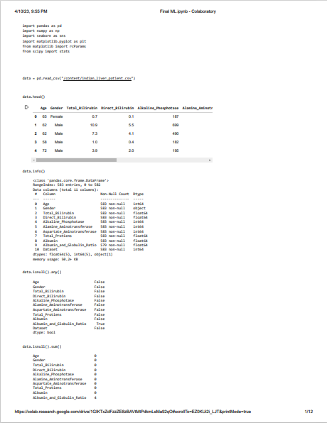Liver_ Patient. Analysis .ipynb

